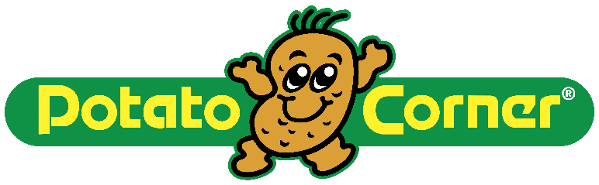

QUALIFICATION FORM

2x2
ID PICTURE

PERSONAL INFORMATION
Last Name | First/Given Names | Middle Name | Name Suffix
Gender | Civil Status | Date of Birth | Age
Country of Birth | Nationality / Citizenship | Country of Current Residence

CONTACT DETAILS
Residence No. |  |  |  | Mobile No.
Business No. |  |  |  | Fax No.
Social Messaging App Used
Preferred Means of Communication
Best Time to Call:
Email Address:
Primary  Home  Address | Line 1
 | Line 2
 | Province

BUSINESS EXPERIENCE
Present
Present Occupation and/or Function
Name of Company |  |  | No. of Years in Company
Company Address |  |  | Company Tel No.
Previous
Previous Occupation and/or Function
Name of Company |  |  | No. of Years in Company
Contact Permission
May we contact your present employer?

BUSINESS INTEREST
Potato Corner Experience
Have you been a customer of Potato Corner?
If Yes, how many times have you visited Potato Corner and what product/s do you order often?
What do you think makes customers come to Potato Corner?
Business Perspectives
What is your main reason for considering a Potato Corner franchise?
What do you think will make you a successful Potato Corner franchisee?
What are your expectations in having a Potato Corner franchise?
What, in your background, will assist you in successfully managing a Potato Corner franchise?
What experience/s have you had in following systems and procedures?
What to you is ‘OPEN COMMUNICATION’?
When you encounter difficulties in your Potato Corner franchise, what will be your plan of action?
To what extent will you be involved in the day-to-day operations of the franchised branch?
Business Financing
What percent of the equity of this franchise business will you own?
What amount of cash will you personally invest in this franchise?
What will be the source of these funds?
Will you and your family completely depend on the income generated from having a Potato Corner franchise?

If YES, what is your income expectation? If NO, what are the other sources of your family income?
Related Business/es
Do you currently have an interest in any restaurant / food business, or any other business ventures?
If yes, please describe such business.
Franchise Marketing & Operations
What are your location preferences?
Who are the immediate markets you can think of for your franchised outlet?
When can you start operating your own franchise?

CREDIT CHECK & FINANCIAL INFORMATION
Are you willing to be subjected to background and credit check by the Franchisor?
References
 | Bank/Credit Reference | Contact Person |  | Contact Number
1
2
3
Declaration of Assets, Liabilities, and Sources of Income
 | Assets  (Real Estate, Stocks/Bonds, Insurances, etc.) | Value  (in Peso) |  | Remarks  (Note which are collateralized, pledged, mortgaged, or have adverse claims)
1
2
3
 | Loans/Liabilities |  |  | Amount  (in Peso)
1
2
3
 | Sources of Income |  |  | Yearly Amount
1
2
3

EDUCATIONAL BACKGROUND
State your educational experience, including name and location of schools, years completed, and degrees earned.

OTHER PERSONAL INFORMATION
Family Information
Spouse’s Name |  |  |  | Spouse’s Occupation
Spouse’s  Date of Birth |  |  |  | Number of Dependents
Security & Background Information
Have you ever been convicted of any crime involving moral turpitude?
► | If YES, please state nature and status.
Is there any pending suit, whether civil or criminal, of which you are a party?
► | If YES, please state nature and status.
Character References
 | Contact Person  (non-family) |  | Contact Number |  | Email Address
1
2
3

ACKNOWLEDGEMENT
PLEASE READ AND SIGN:
I hereby represent that all of the above answers are true and correct to the best of my knowledge and belief. I recognize Cinco Corporation, the Franchisor for Potato Corner, is not in any way obligated to offer a franchise to me because of our execution of this document. I understand that any false statement on this application shall be considered sufficient cause to deny further consideration. I understand that any inquiry regarding my character, personal characteristics and financial background maybe conducted as a result of information required by Cinco Corporation.
Printed Full Name
Signature

